WEBSITE MANAGEMENT & DESIGN
- WEB SPECIFICATIONS
ForeverThrift is a thrifting shop that resells old, second-hand clothes and jewelry at a cheap price. At ForeverThrift, we believe that style should be affordable to everyone.
a) Objective
The goal of the website is to display clothes, accessories and make it easier to browse available items. This will help ForeverThrift increase its reach, which in-turn should help the business attract customers and make profits by promoting the business.
GOALS
- To increase sales and profits.
- To deliver a smooth experience.
- Promote environmental sustainability.

b) Target Audience
The primary target audience are young people and adults who enjoy ‘fashion on a budget.’ Demographic includes people of ages 16 – 30, because they are the most active age group on online shopping platforms and have a high technical literacy, of all genders, who have a low to middle income. Research shows that 42% of Gen-Z consumers purchased secondhand clothing in the past year, and that millennials make up about 45% of thrift shoppers, (Chandrasekaran, 2026).
c) Type of Website
This website will function as an e-commerce, consisting of a homepage that will display products on sale, navigation for price range and clothing type, as well as an about, a contact page and a form for customers to fill to ask about their experience and suggestions for the website.
The website should be accessed from any browser and mobile device.
- INFORMATION DESIGN & TAXONOMY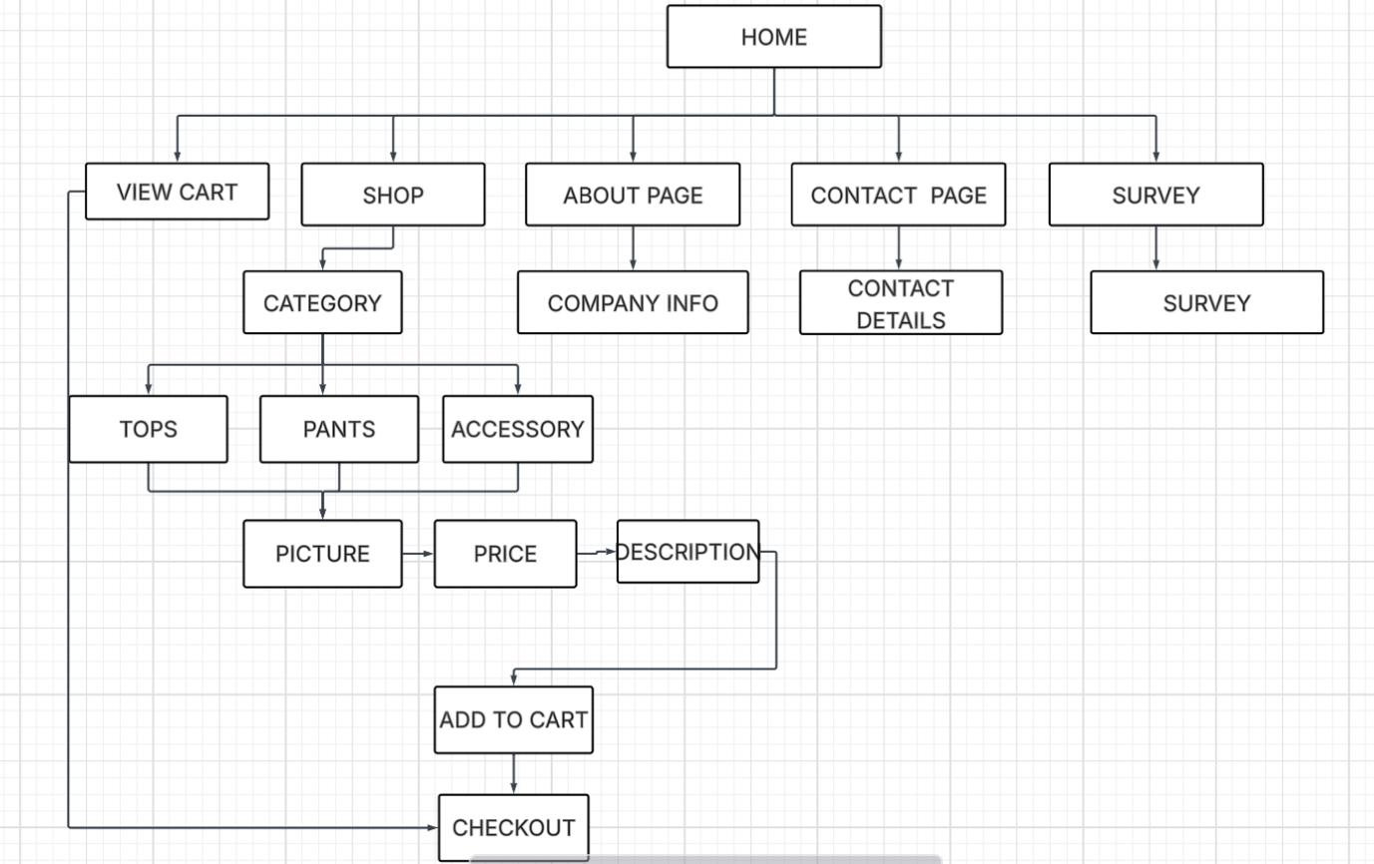
- PAGE TEMPLATE DESIGN
Wireframe to demonstrate navigation and page layout.

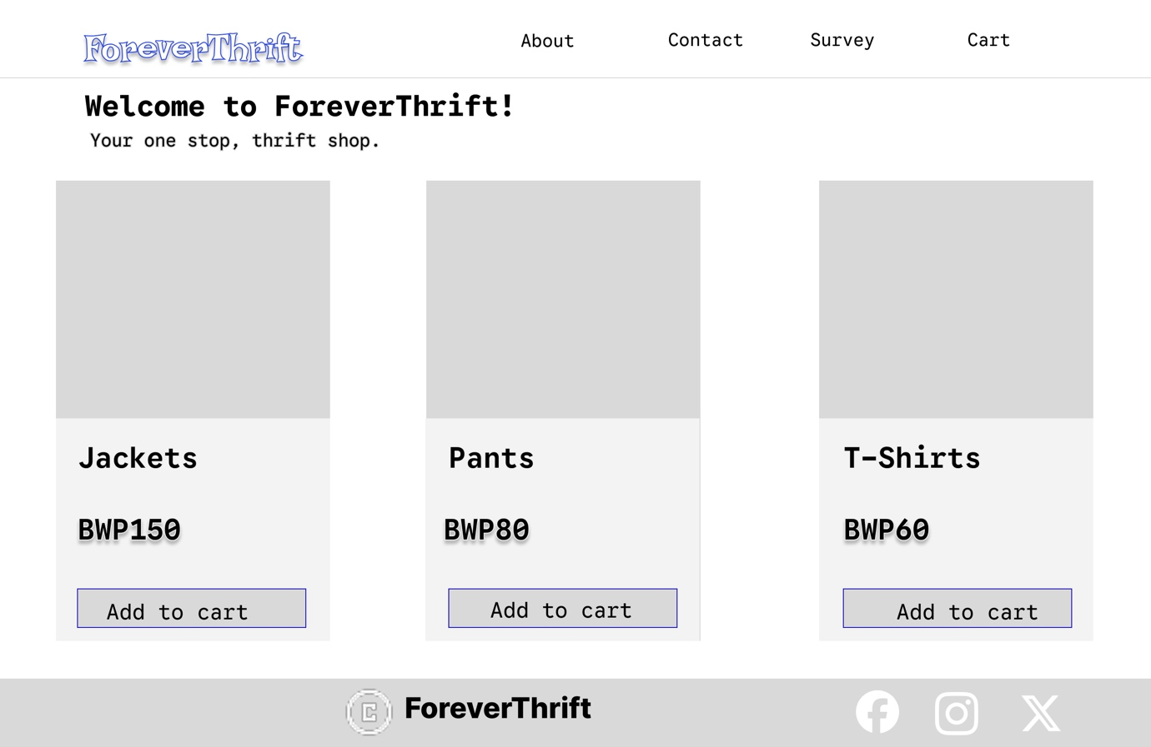
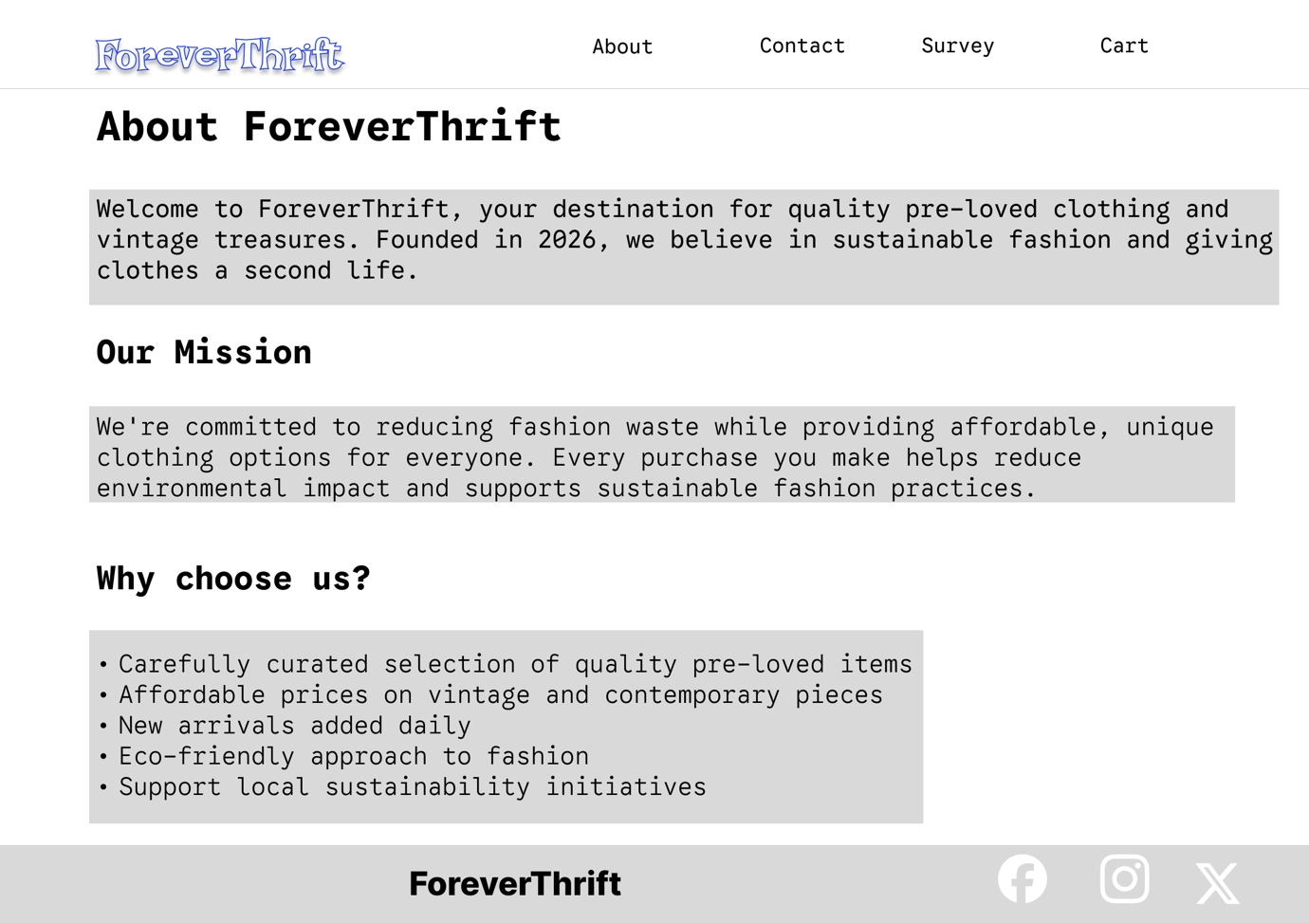

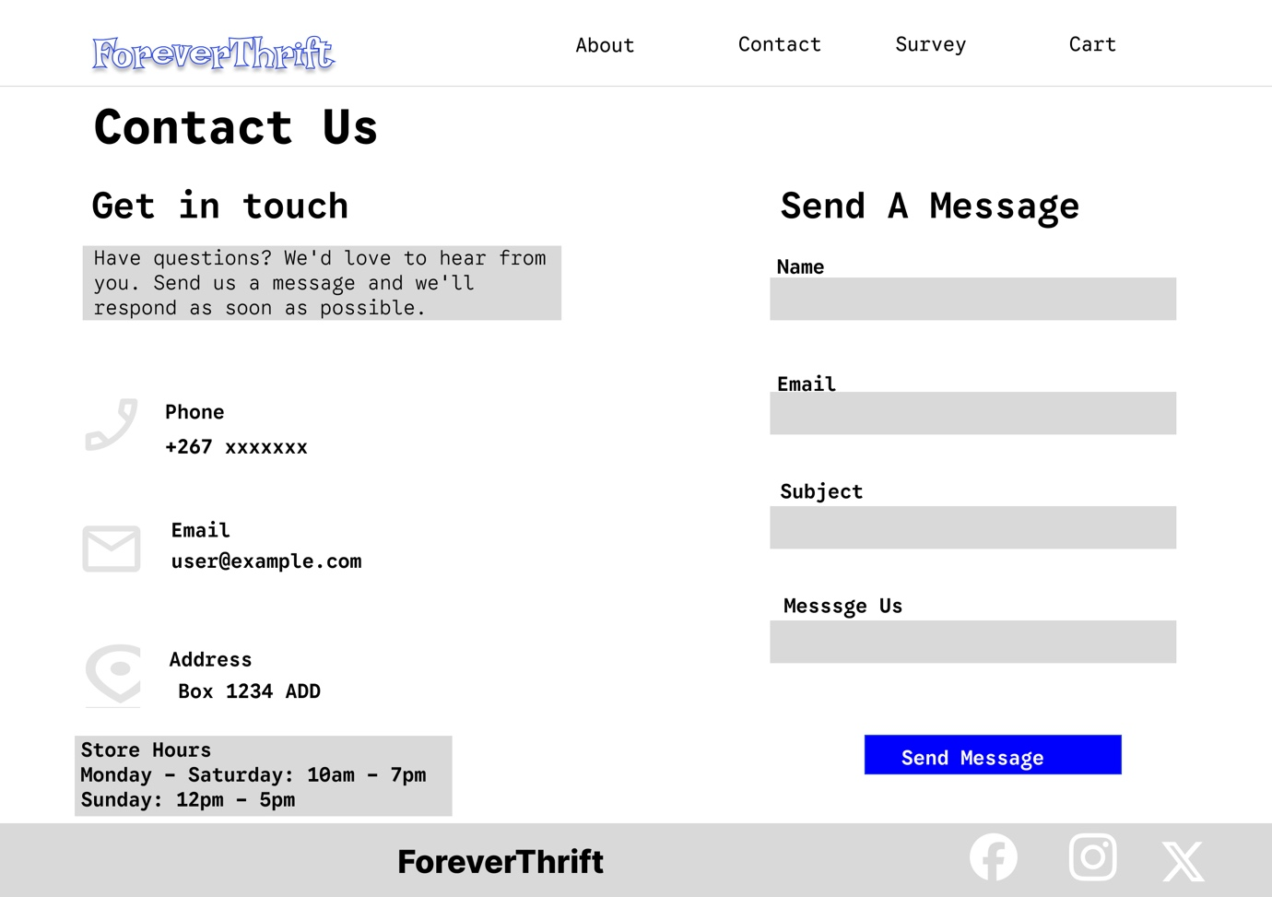
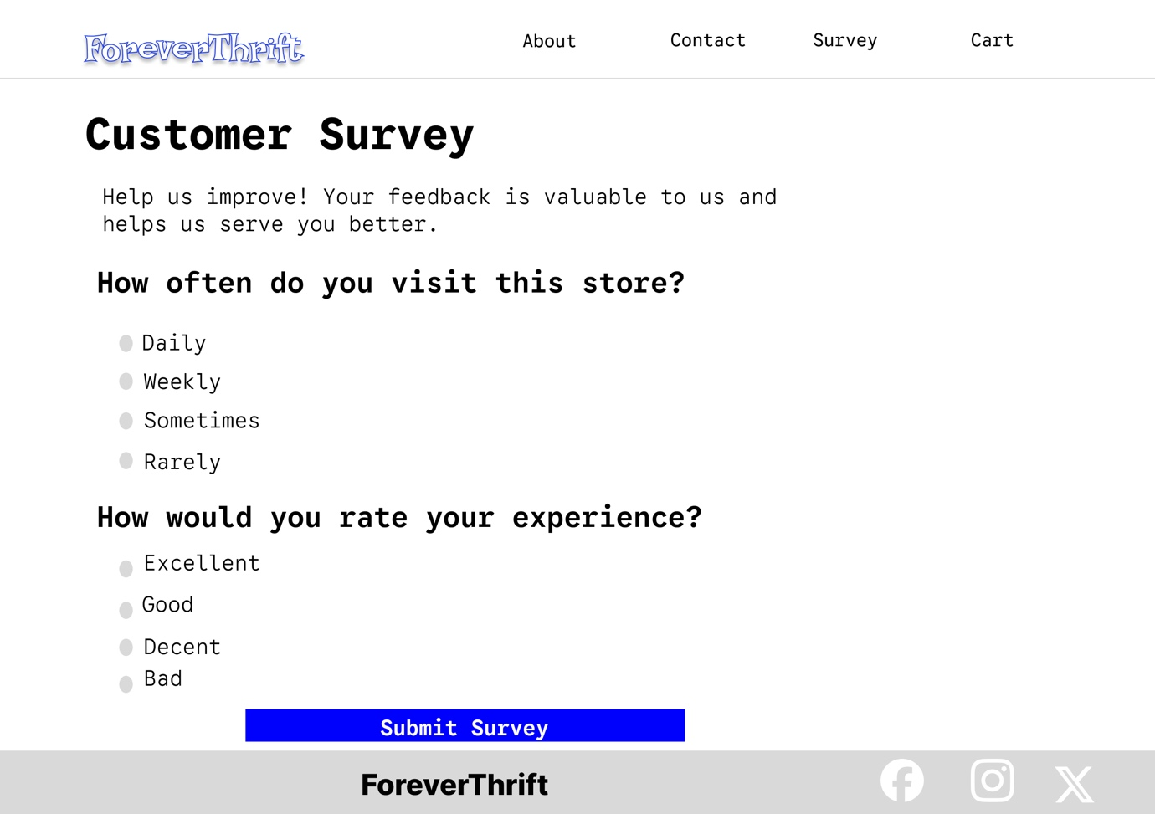
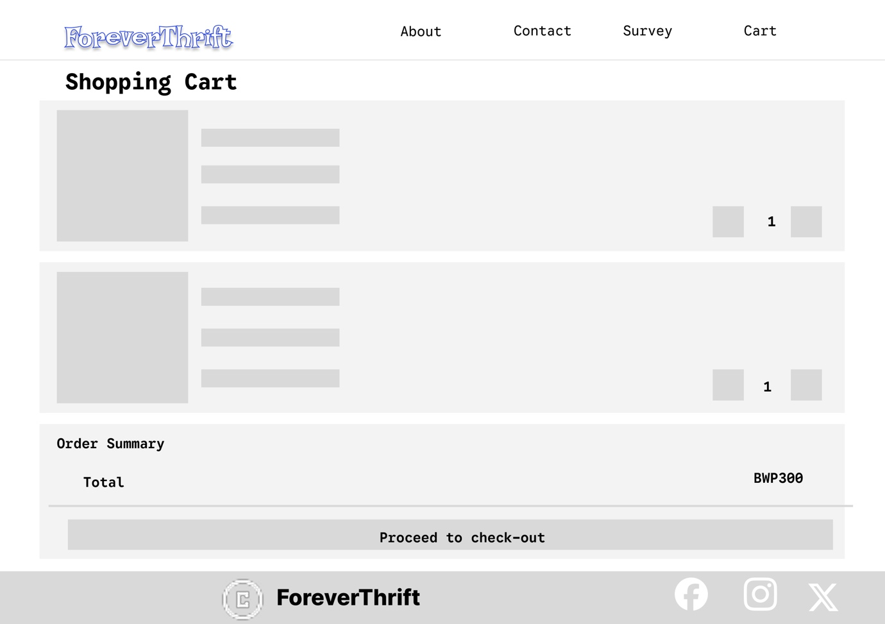

- TECHNICAL BRIEF
Technologies used:
LucidChart: Flowchart diagrams to show page navigation.
Visual Studio Code: Source code editor that supports HTML and CSS.
CSS: A style sheet language used for page styling in HTML documents.
HTML: A markup language that is used to create and defines the page structure.
Bootstrap: To add a responsive design.
GitHub Pages: Hosting the website and storing website files online.
- QUALITY ASSURANCE
Tests will be conducted on different web browsers (Chrome, Safari)
The website will also be tested on mobile responsiveness as well as devices of different screen sizes.
The website will be tested on layout and navigation links.
- PUBLISHING & PROMOTION
The website will be published and hosted on GitHub pages. Promotion will happen through the sharing of a link (https://mogobearona.github.io/cse25-312/)of the page through social media.
- FUTURE DEVELOPMENTS
Future developments for the website may include customers being able to sell their own products on the website, user accounts, animations and availability on more web browsers and devices.

